Design and code explanation

First, we have the main function in the Simulator.cpp file which basically is the entry point of the programme which represent the starting basic interface. It welcomes the user to an interface which welcomes them to ISRO and tell them something about ISRO. Which also tell the uses what type of mission that we offer in ISRO.

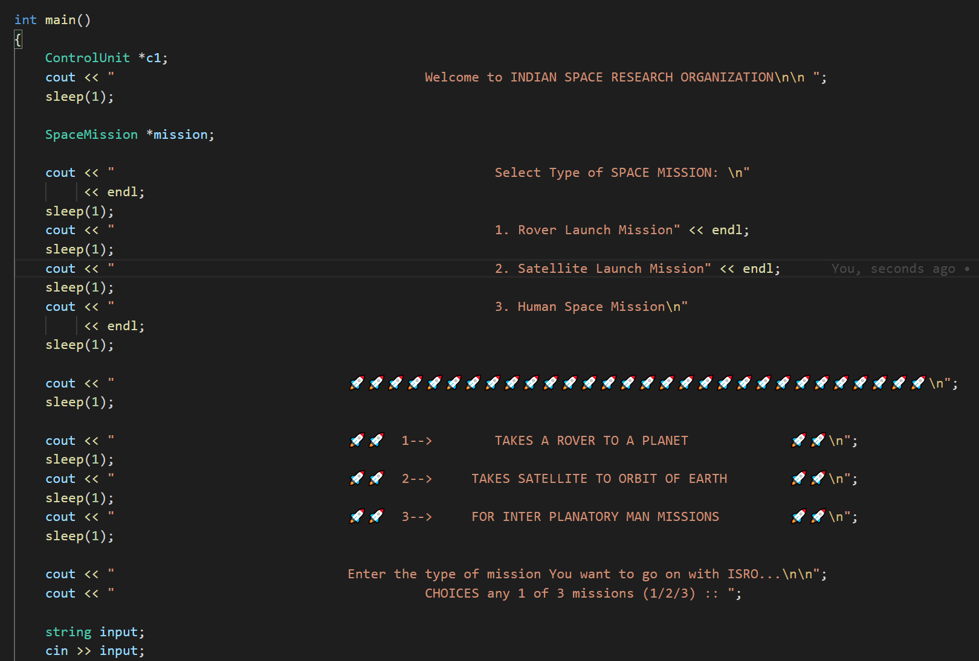

Then we take an input in the form of the string which has 3 options for different type Rocket missions. We have taken
ControlUnit *c1
SpaceMission *mission;

Class pointers. then to simulate we will simulate the space mission punter pointing to the given input and controlunit is also given as a parameter in each simulate to simulate different parts of the mission.

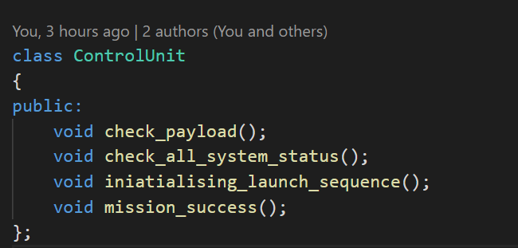

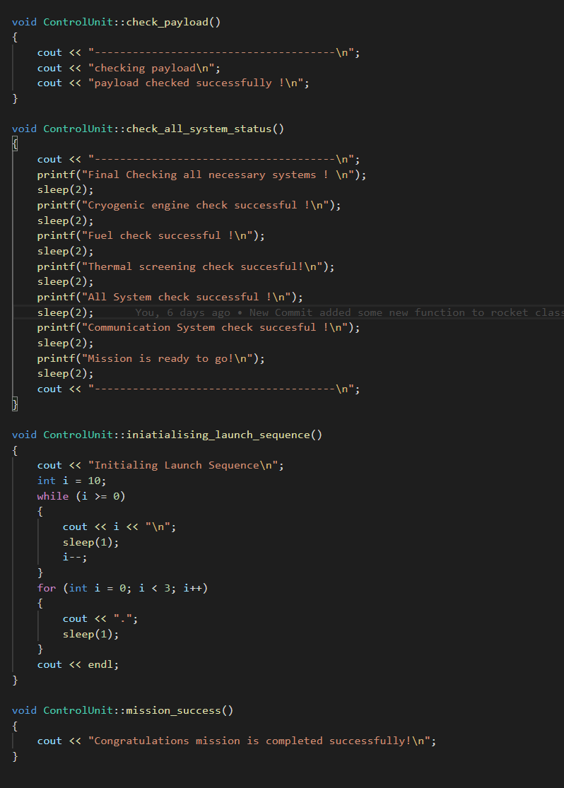

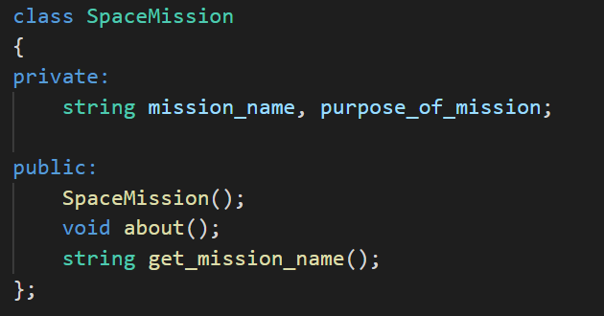

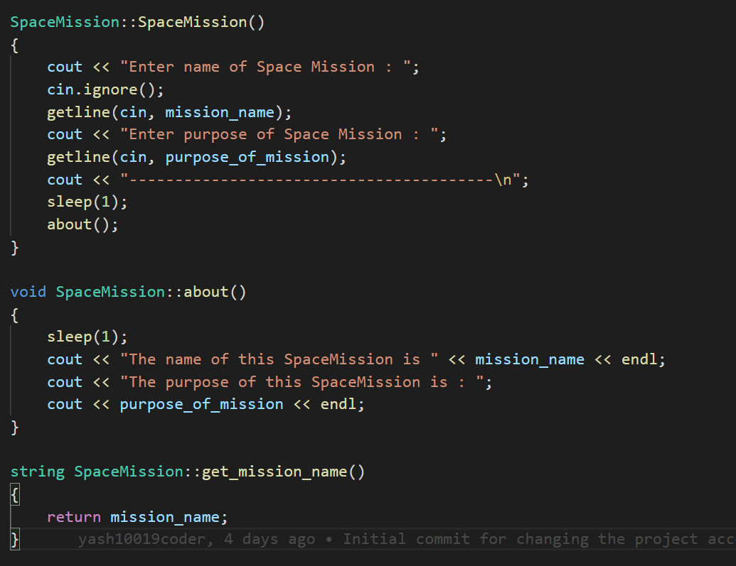

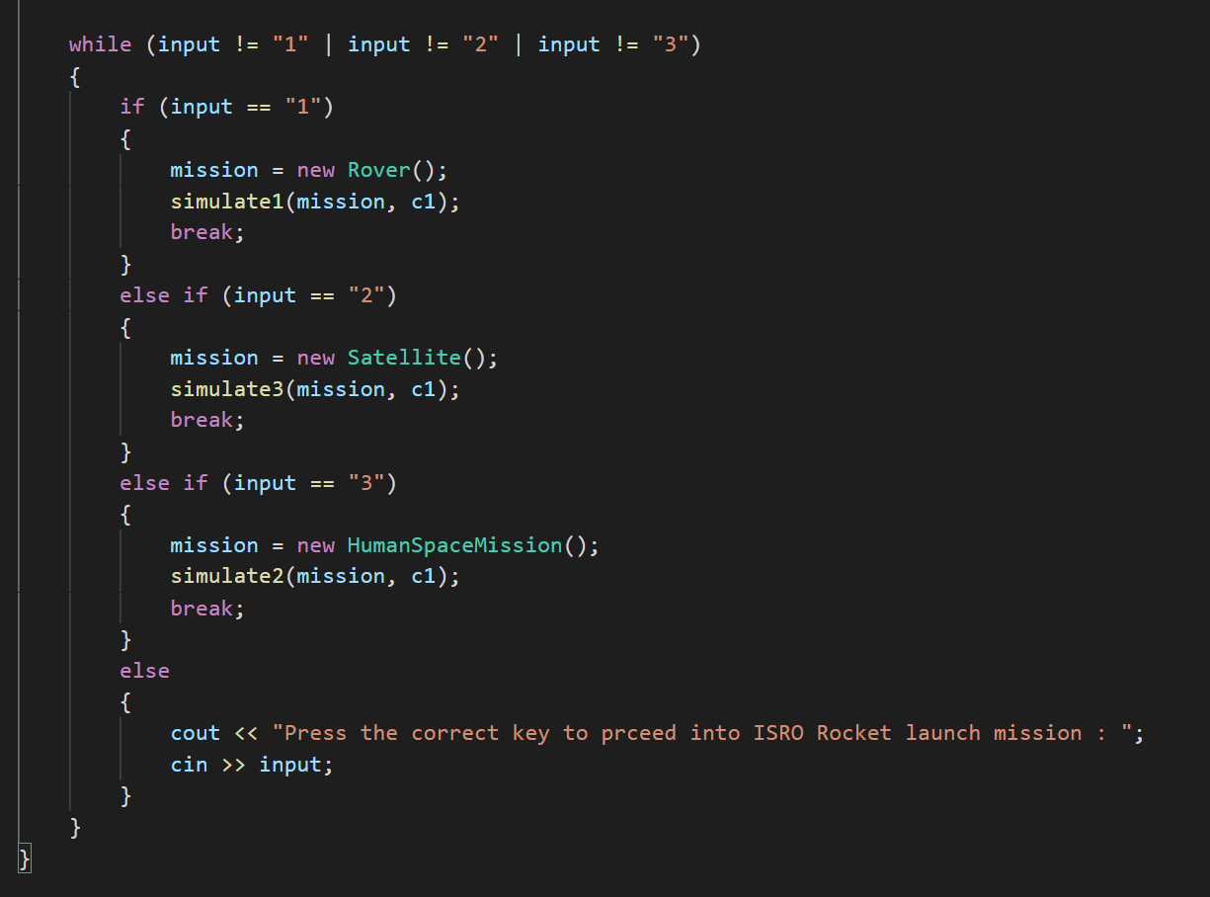

So, this allows us to take input and if input is wrong, we take input again and again after that we simulate the selected mission by the user. First, we create a pointer of base class SpaceMission then we create the object of the derived or inherited classes like Rover or Satellite or Human exploration then first the object of the base class SpaceMission is created then its constructor is called then the objects of the further derived classes are created in order this is how inheritance works and it is very useful as it implements the hierarchical approach

1. Rover Launch Mission

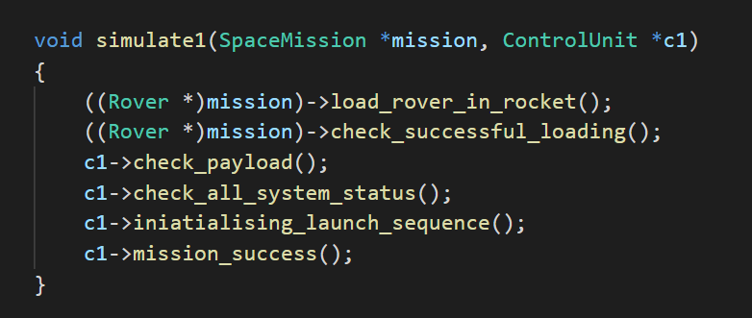

The function

((Rover *)mission)->load_rover_in_rocket();
((Rover *)mission)->check_successful_loading();

In these two is a function of Rover class which is inherited from SpaceMission class. And here we have made a SpaceMission type pointer. So we simply cannot use Rover class function by ‘object.functionName()’ method. To access that functions we have to use typecasting. In typecasting we specify that to which class this function belongs. The method of typecasting is: ((derived_class *)base_class_pointer)-> derived_class_function_name().
Same thing is applied to check_successful_loading () function.

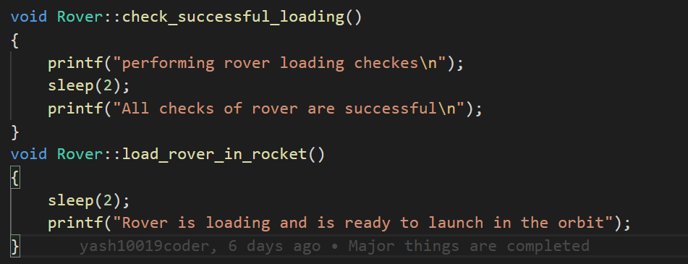

2. Satellite Launch Mission

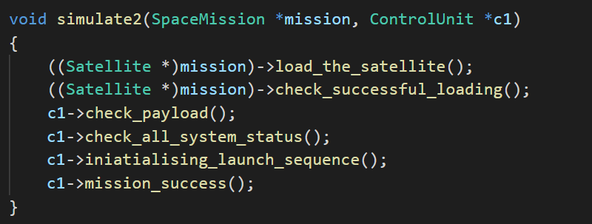

((Satellite *)mission)->load_the_satellite();
((Satellite *)mission)->check_successful_loading();

In these two is a function of Satellite class which is inherited from SpaceMission class. And here we have made a SpaceMission type pointer. So we simply cannot use Satellite class function by ‘object.functionName()’ method. To access that functions we have to use typecasting. In typecasting we specify that to which class this function belongs. The method of typecasting is: ((derived_class *)base_class_pointer)-> derived_class_function_name().
Same thing is applied to check_successful_loading() function.

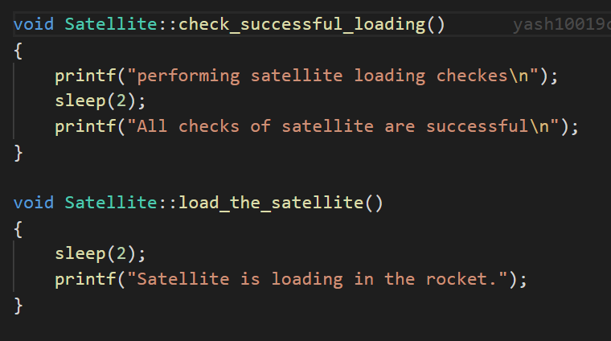

3. Human Space Mission

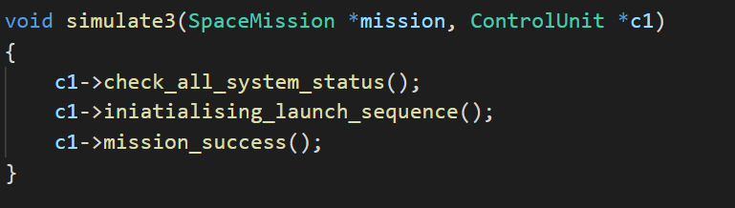

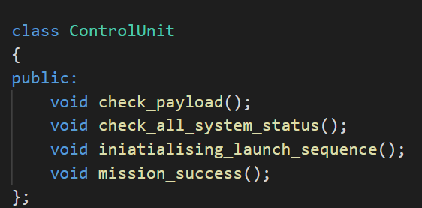

We have some functon defined in ControleUnit class which we are using by aggrigation
( a type of Association) for different missions.
